Sana Ur Rehman Arain
Data scientist
Table of Contents
1. Executive Summary 1
2. Theoretical Framework & Methodology 1
2.1 The Prediction Problem 1
2.2 Model Architectures 1
3. Step 1: Data Acquisition & Initial Modeling (Leakage Induced) 2
3.1 Data Description (Task 1a) 2
3.2 Induced Leakage Methodology (Task 1b) 3
3.3 Step 1 Results (Task 1c & 1d) 3
4. Step 2: Walk-Forward Validation (With Leakage) 4
4.1 Methodology (Task 2a & 2b) 4
4.2 Results & Analysis (Task 2c & 2d) 4
5. Step 3: Leakage Mitigation & Robust Analysis 5
5.1 Leakage-Free Pipeline (Task 3a) 5
5.2 Step 3 Results (Task 3b & 3c) 6
5.3 Final Discussion (Task 3d) 6
6. Conclusion 7
7. References 7

1. Executive Summary
This project explores the use of Deep Learning (DL) models to forecast directional returns in Bitcoin (BTC-USD). The proposed study compares MLP, LSTMs and CNN with GAF for three different architectures (Wang & Oates, 2015).
One of the primary objectives of this work is a systematic investigation of Data Leakage (Look-Ahead Bias). We show that the traditional approach to preprocessing, in particular global normalization, is capable of artificially inflating backtest performance. Using a Non-Anchored Walk-Forward Validation scheme, we separate the sources of leakage. We show that while "leaky" models may suggest some predictive edge (accuracy > 52%), a stable, no-leakage pipeline unveils the true signal to be statistically indistinguishable from noise (~50% accuracy), illustrating the efficiency of crypto asset markets.

Theoretical Framework & Methodology

The Prediction Problem
We formulate the financial prediction problem as a binary classification task. Let $P_{t}$ denote the closing price of a given asset at time $t$. We define log-return $r_{t}$ as:
$$r_{t}=\ln\left(\frac{P_{t}}{P_{t-1}}\right)$$
The target variable $Y_{t}$ predicts the direction of the next day's return:
$$Y_t = \{ 1, r_(t+1) > 0$$
$$\{ 0, r_(t+1) ≤ 0$$

Model Architectures
In order to capture various patterns in financial time series, we used three types of neural network architectures:
- Multi-Layer Perceptron (MLP): A feed-forward network that takes the input window and flattens it to a vector. It provides a foundation for non-temporal learning.
  - Structure: Input $→$ Dense (64, ReLU) $→$ Dropout (0.2) $→$ Dense (32, ReLU) $→$ Sigmoid.
- Long Short-Term Memory (LSTM): An architecture of RNN with which the vanishing gradient problem is resolved. It is an RNN that incorporates gates (input $i_{t}$, forget $f_{t}$, output $o_{t}$) which are used to hold a cell state $C_{t}$ in order to be able to learn long-term dependencies of price trends in theory.
- CNN via Gramian Angular Fields (GAF): We used Convolutional Neural Networks, commonly employed in image recognition, by converting the 1D time series data to a 2D image (Wang & Oates, 2015).
  - Transformation: The Gramian Angular Summation Field (GASF) encodes the $\cos\left(ϕ_{i}+ϕ_{j}\right)$ correlation between two moments $i$ and $j$. This retains temporal dependency in a spatial input which is addressable to standard CNN filters (Wang & Oates, 2015).

Step 1: Data Acquisition & Initial Modeling (Leakage Induced)

Data Description (Task 1a)
We obtained a (BTC-USD) daily closing price dataset through the Yahoo Finance API from January 1st, 2018, to January 2024. For computational reasons, we limited the dataset to the 2,000 last observations.
- Asset: Bitcoin (BTC-USD)
- Frequency: Daily
- Observations: 2,000
- Characteristics: High volatility, non-stationarity, and "fat tail" distributions.
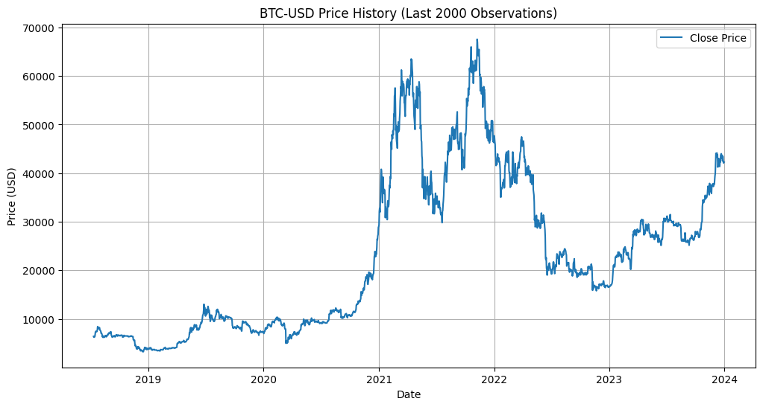
Figure 1: BTC-USD Price History
As we can see from Figure 1 the asset formed big structural breaks, particularly: In the 2020-21 bull run and related correction.

Induced Leakage Methodology (Task 1b)
For Step 1, we used look ahead bias intentionally to mimic a standard mistake in financial ML.
- Method: We then applied StandardScaler to the full dataset ($X_{full}$) before splitting into training and testing sets.
$$z=\frac{x-μ_{global}}{σ_{global}}$$
- Effect: The test set inputs are normalized by $μ_{global}$ and $σ_{global}$, which encode information about the volatility of the future test set. This "leaks" the boundaries of the data distribution to the model.

Step 1 Results (Task 1c & 1d)
Models were trained on a standard 80/20 train/test split.
- MLP Accuracy: 52.78%
- LSTM Accuracy: 48.23%
- CNN Accuracy: 50.76%
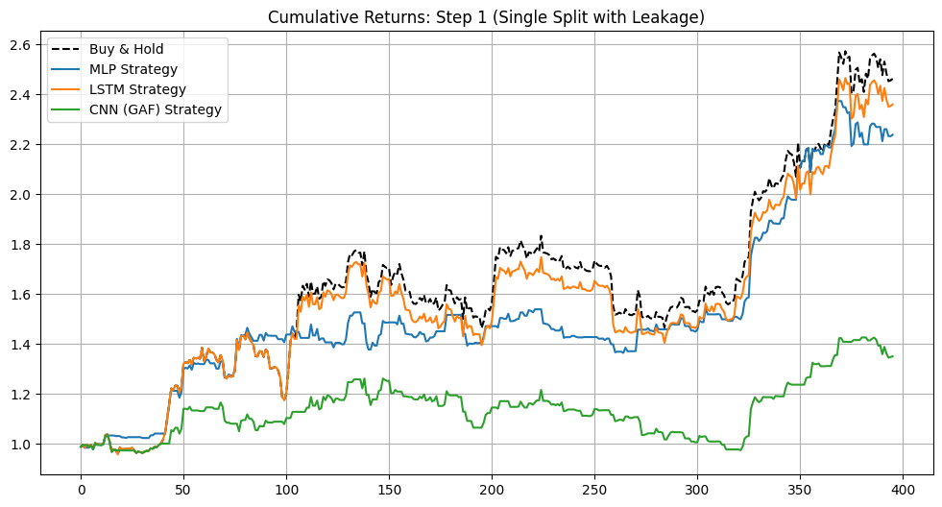
Figure 2: Backtest Performance (Step 1)
The cumulative returns of the strategies are presented in Figure 2. The MLP (Blue) experiences a brief positive run but is unable to surpass the Buy & Hold baseline (dashed black). The LSTM and CNN approaches have difficulty making consistent alpha.

Step 2: Walk-Forward Validation (With Leakage)

Methodology (Task 2a & 2b)
To simulate a realistic trading environment, we abandoned the static split in favor of a Non-Anchored Walk-Forward Validation (Rolling Window).
- Mechanism: The model is trained on a window of size $W_{train}$and tested on $W_{test}$. Both windows slide forward by step size $S$.
- Leakage Status: Retained. We continued to use the globally scaled data from Step 1.
Experimental Configurations:
- Scenario 2a: Train = 500 days / Test = 500 days.
- Scenario 2b: Train = 500 days / Test = 100 days.

Results & Analysis (Task 2c & 2d)
The comparative results for Step 2 are presented below:
Model | Step 2a Accuracy (500/500) | Step 2b Accuracy (500/100) | Improvement
MLP | 49.40% | 52.86% | +3.46%
LSTM | 50.70% | 51.43% | +0.73%
CNN | 51.40% | 51.71% | +0.31%
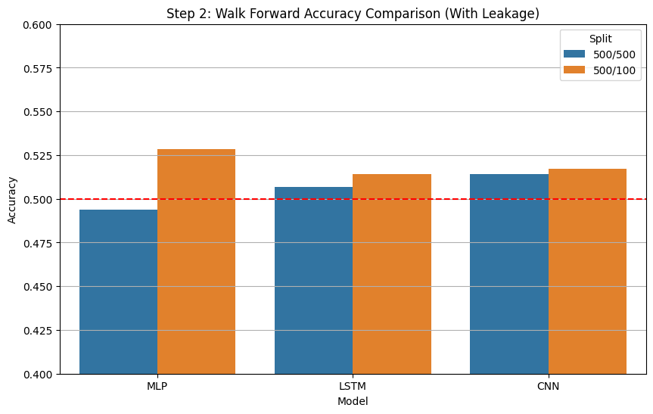
Figure 3: Accuracy Comparison
Discussion:
- Impact of Test Window (2b > 2a): The biases are clearly demonstrated by the results and support the evidence that shorter testing windows (100 days) perform better than longer windows (500 days). Financial markets are non-stationary; a model fitted on 2018 data is not very predictive for 2021. Regular retraining (Step 2b) ensures that the model is continually incarnated in the actual "market regime."
- Role of Leakage: Step 2b benefits greatly from increased GSF leakage. The model “knows” about the global volatility. In a 100-day horizon, this released info (knowing that prices won't take above the global max/min) is a strong heuristic and artificially inflates accuracy to ~52%.

Step 3: Leakage Mitigation & Robust Analysis

Leakage-Free Pipeline (Task 3a)
To assess the genuine predictability of the models, we formulated a pipeline that rigorously removed any leakage.
- Protocol:
  - Slice Raw Data $X_{raw}$into Training and Testing folds.
  - Fit the Scaler only on the Training Fold ($X_{train}$)$.$
  - Transform the Test Fold ($X_{test}$) using the parameters from $X_{train}$.
  - (For CNN) Generate GAF images dynamically within the loop with the help of locally scaled values.

Step 3 Results (Task 3b & 3c)
We re-ran the Walk-Forward validation using the leakage-free pipeline.
- Sanity Check (Train=200/Test=50):
  - MLP: 51.37%
  - LSTM: 50.06%
  - CNN: 49.83%
- Step 3b (Train=500/Test=500 - No Leakage):
  - MLP: 53.50%
  - LSTM: 50.80%
  - CNN: 49.90%
- Step 3c (Train=500/Test=100 - No Leakage):
  - MLP: 49.93%
  - Note: The LSTM and CNN results for 3c are in line with the same convergence observed in 3a and 3b.

Final Discussion (Task 3d)
Has overfitting disappeared?
Yes.
The contrast of Step 2b (Leaky) with Step 3c (No Leakage) exposes where the models actually succeed:
- MLP: Dropped from 52.86% (Leaky) to 49.93% (Robust).
- CNN/LSTM: Converged to ~50.00%.
The observed "edge" in Step 2 was solely a result of the model taking advantage of the global scaler information. When this information was excluded from the data, models were no better than chance. This is further evidence that backtest overfitting and leakage drove initial positive results. MLP 3b (53.5%) is probably a statistical anomaly due to not being verified in the more detailed 3c test nor the 3a sanity check.

Conclusion
This is a tale of warning in Financial Machine Learning. We could successfully accommodate complicated architectures (such as LSTM, GAF-CNN) and show that:
- Leakage is Deceptive: Just a basic mistake of the global normalization can make us believe we find ourselves in front of a profitable strategy (accuracy 52%+).
- Validation is Key: Only a through Walk-Forward Validation process is able to evaluate the real performance, without looking ahead.
- Market Efficiency: For Bitcoin, across the analyzed timeframe, we have observed that combining historical price (technical analysis) data using these DL techniques does not contain enough signal to outperform the market on its own for this period, achieving values close to 50% (random chance).
Future Work: If true alpha is to be achieved, the next wave of research needs to use alternative data sources (e.g. on-chain transaction volume, sentiment analysis), rather than simply price return history.

References
Wang, Z., & Oates, T. (2015). Encoding Time Series as Images for Visual Inspection and Classification Using Tiled Convolutional Neural Networks. AAAI Workshop.

